**System Analysis**

Analysis part represents the customer requirements e.g. Analysis step include stepwise specification of the program or process to represent requirements, analysis includes three domain

* Information domain
* Functional domain
* Behavioral domain

**3.1 Analysis model**

Analysis includes three domains

* Behavior modeling
* Functional modeling
* Architectural modeling

**3.2 UML diagrams:**

Design modeling uses a combination of text and diagrammatic forms to depict the requirements for data, function and behavior in a way that is relatively easy to understand and more important, straightforward to review for correctness and consistency.

A diagram is a graphical presentation of a set of elements most often rendered as a connected graph of vertices (things) and arcs (relationship).These diagrams are drawn to visualize a system from different perspectives so a diagram into a system.

**3.3 Behavioral Modeling**

**3.3.1 Use case Diagram:**

It shows a set of use cases and actors (a special kind of class and their relationships).Use case diagrams address the static use case view of system. These diagrams are especially important in organizing and modeling the behavior of a system.

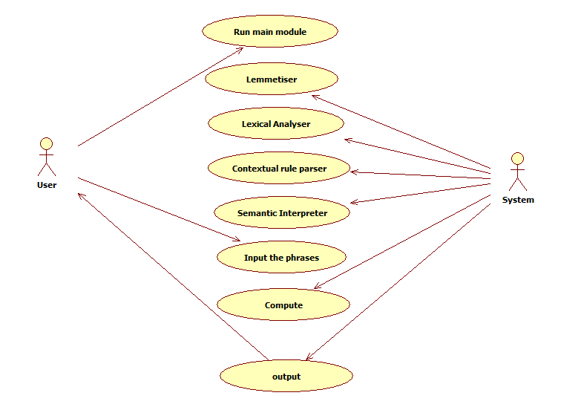

**3.3.2 Sequence diagram:**

It shows the sequence of events that occur during the runtime of the software. We can also detect the flow of control from the basis of this diagram.

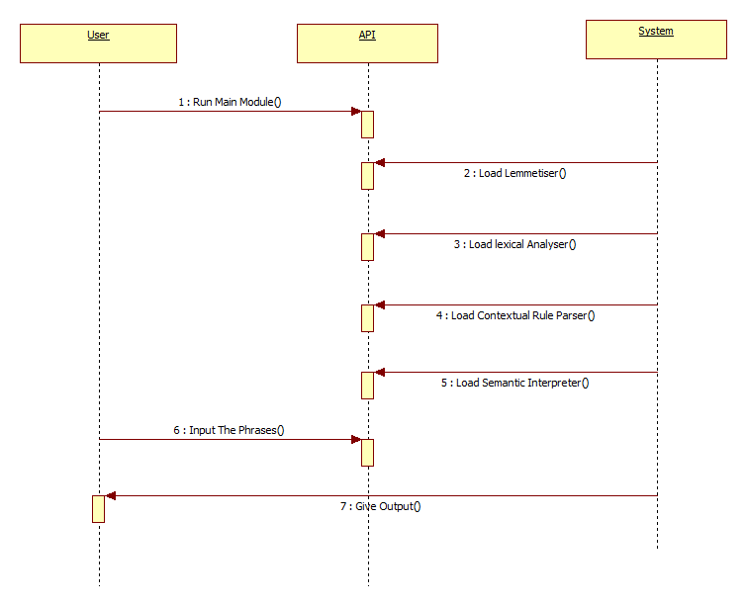

**3.3.2 Activity diagram:**

It shows the processing of software through certain decision making points. Also the conditions when a fork is obtained in the flow of control, it shows the possibilities of where the processing will go from there.

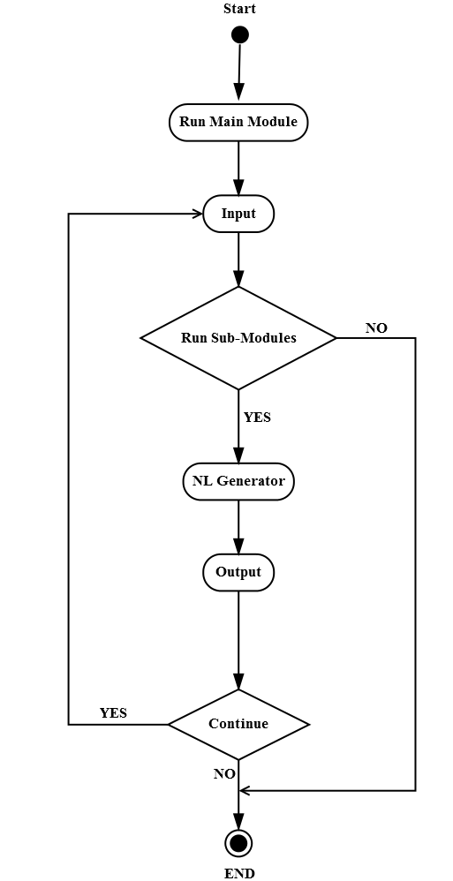

**3.4 Functional Modeling**

In the functional modeling it describes the function of the propose system. It consists of two diagrams.

They are as follows:

* Dataflow diagram
* Control flow diagram

**Dataflow diagram**

Dataflow diagram (DFD) is also called as ’Bubble chart’ is a graphical technique which is used to represent information flow, and transformers those are applied when data moves from input to output.

**Level 0 DFD:**

This diagram includes the overview of the system at a glance.

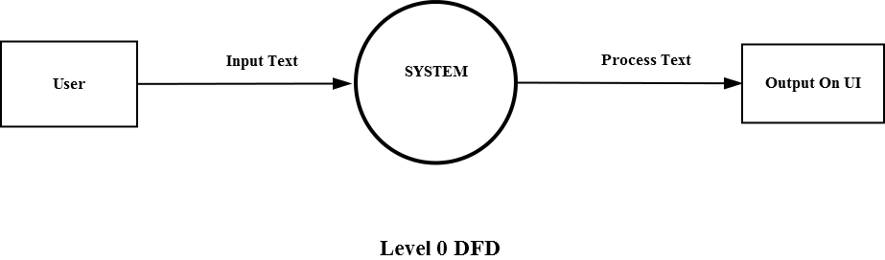

**Level 1 DFD**

This diagram gives somewhat more precise information about the actual processing of the software.

